

Activity Manual- Testing a Feature Store for Vodafone Billing AI

Prepared for:

Date: 18th Nov 2025

Prepared by:
Document Name: Lab Manual Document Number MLOps
Contributor:

Contents
1. Activity Scenario 3
2. Lab Architecture 3
3. QA Validation Steps 3
1. Step 1 – Validate Raw Data 3
2. Step 2 – Generate Feature Store 4
3. Step 3 – Compare Raw Data vs Feature Store 4
4. Step 4 – Validate Updates 4
5. Step 5 – Handle Missing Data 4
6. Step 6 – Detect Duplicates 5
7. Step 7 – Confirm AI Model Input 5
8. Step 8 – Validate AI Prediction 5
9. Step 9 – Validate Prediction Change 6
10. Step 10 – Raise Defect (if needed) 6
4. Final QA Checklist 6
5. Learning Outcomes 6

Activity Scenario
A developer has built a Feature Store for Vodafone's Billing Anomaly Detection AI. Before the model is deployed to production, the QA team must verify that the Feature Store is correct.
.You are a QA Engineer in Vodafone’s AI team. Your task: Validate the Feature Store that feeds the Billing Anomaly Detection AI model. The goal is to ensure data correctness, reliability, and system behavior before production deployment.

Lab Architecture

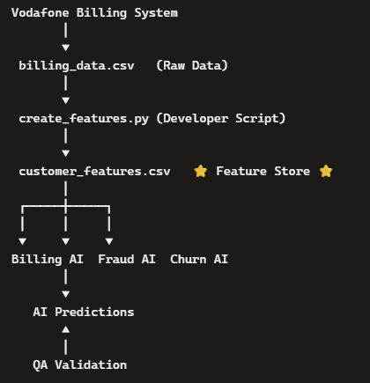

QA Validation Steps

Step 1 – Validate Raw Data
- File: data/billing_data.csv
- Checklist
  - ✔ Customer IDs present
  - ✔ No empty values
  - ✔ Numbers valid
  - ✔ No duplicates
# Expected Result: Raw data is valid.

Step 2 – Generate Feature Store
- File: scripts/create_features.py
- Run:
cd scripts
python create_features.py
# Expected Result: Feature Store Created Successfully

Step 3 – Compare Raw Data vs Feature Store
- File: customer_features.csv
- Activity: Compare values in raw vs feature store.
- Tester Question: Do values match?
#Expected Answer: ✅ Yes

Step 4 – Validate Updates
- Modify billing_data.csv (e.g., DataGB = 10 → 20).
- Re-run script.
cd scripts
python create_features.py
- Tester Question: Did MonthlyDataUsage update?
#Expected Answer: ✅ Yes

Step 5 – Handle Missing Data
- Delete BillAmount for one customer.
- Re-run script.
cd scripts
python create_features.py
- Tester Question: How is missing data handled?
# Possible Outcomes:
  - ✅ Error displayed
  - ✅ Blank value stored
  - ✅ Default value assigned
- Discussion: Define expected business rule.

Step 6 – Detect Duplicates
- Add duplicate CustomerID in raw data.
- Re-run script.
cd scripts
python create_features.py

- Tester Question: Are duplicates present in Feature Store?
# Expected Answer: ❌ No
- If duplicates exist → Raise Defect

Step 7 – Confirm AI Model Input
- Run:
cd scripts

python train_model.py
# Expected Result: AI Model Trained Successfully
- Tester Question: Which file should model use?
Expected Answer: ✅ customer_features.csv

Step 8 – Validate AI Prediction
- Run:
python predict.py
# Expected Result: Prediction : Normal Billing

- Tester Question: Was prediction generated?
# Expected Answer: ✅ Yes

Step 9 – Validate Prediction Change
- Modify customer_features.csv (e.g., MonthlyDataUsage = 12 → 20).
- Re-run prediction.
# Expected Result: Billing Anomaly Detected

Step 10 – Raise Defect (if needed)
Sample Defect Report
- Title: Feature Store not updated after source data change
- Steps:
  - Change DataGB in raw file
  - Run create_features.py
  - Check Feature Store
# Expected: Updated value
- Actual: Old value remains
- Severity: High

✅ Final QA Checklist
Test Case | Expected Result | Status
Raw data validated | Pass | ☐
Feature Store created | Pass | ☐
Raw data matches Feature Store | Pass | ☐
Feature Store updates after data changes | Pass | ☐
Missing values handled | Pass | ☐
Duplicate records detected | Pass | ☐
AI model reads Feature Store | Pass | ☐
AI prediction generated | Pass | ☐
Prediction changes after feature update | Pass | ☐
Defect documented | Pass | ☐

Learning Outcomes
By completing this lab, QA Engineers will:
- Validate raw input data quality.
- Verify correctness of feature engineering.
- Detect missing values, duplicates, and update issues.
- Confirm AI models consume the latest Feature Store.
- Validate prediction changes based on feature updates.
- Document defects with proper severity and steps.
This mirrors real QA work in MLOps: focusing on data validation, feature correctness, AI inputs, and system behavior — not building ML algorithms.
Would you like me to also restructure this into a formal Test Case Document format (with Test ID, Preconditions, Steps, Expected Result) so it looks like a professional QA deliverable? That would make it even closer to how testers present assignments in interviews.

